**TUẦN 13 – AV9**

**THEME 4: LEARNING A FOREIGN LANGUAGE**

**WRITE (HS TỰ HỌC)**

**THEME 5: THE MEDIA - LISTEN AND READ**

**PART 1: THEME 4: LEARNING A FOREIGN LANGUAGE - WRITE**

**(HƯỚNG DẪN HS TỰ HỌC)** [**https://youtu.be/cQQBZ1XFYwc**](https://youtu.be/cQQBZ1XFYwc)

**Vocabulary:**

1. inquiry (n) : sự điều tra, sự hỏi

2. formal (adj.) : trang trọng

3. include (v) : bao gồm

4. recipient (n) /rɪˈsɪpiənt/: người nhận

5. advertisement   (n) /ˌædvərˈtaɪzmənt /: mục quảng cáo

6. edition (n) /ɪˈdɪʃn/ : ấn bản

7. fee (n) : học phí

8. detail (n): chi tiết

9. necessary (adj.) : cần thiết

10. Look forward to + V-ing : mong = be excited about + V-ing

11. faithfully (adv.) : trung thành, trung thực

Yours faithfully: chân thành (thường viết cuối thư)

12. express   (v) : biểu hiện

13. interest (n) : sự quan tâm

14. state (v) : phats biểu, nói rõ

15. supply(v) : cung cấp

16. polite (adj.) : lịch sự,

17. closing (n) : sự kết thúc

**A letter of inquiry is a for information or action . In all formal letters, you must include the addresses of the writer and the recipient.**

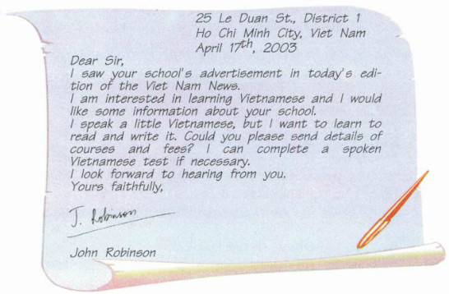

**Task 1:  Read this letter.**

**Task 2:  Read the advertisements in exercise 5. READ again. Choose one of the schools you want to attend to improve your English. Write a letter of inquiry to the institution requesting far more information Cibuut the courses and fees. Follow the Outline below.**

|  |
| --- |
| **OUTLINE**  **Introduction:**  - Say how you come to know about the Institution (advertisement on newspaper / watch on TV)  - Express your interest (want to know more information)  **Request:**  - State how good your English is; exactly what kind of information you want  Further information: Say you are ready to supply more information about your English / study (record of study) if necessary.  **Conclusion:** End with a polite closing |

Dear Sir/ Madam,

I saw your institution’s advertisement in today’s local newspaper.

I am interested in learning English and I would like some more information about your school.

I can speak a little English, but I want to learn to speak more fluently and write well. Could you please send me details of the courses and the fees?

I look forward to hearing from you.

Sincerely yours,

Robert Johnson.

**PART 2: THEME 5: THE MEDIA - LISTEN AND READ**

[**https://www.youtube.com/watch?v=3jNt-icslNI**](https://www.youtube.com/watch?v=3jNt-icslNI)

VOCABULARY

A.

1. media (n): phương tiện thông tin đại chúng

2. invent (v) : phát minh

were invented (n) : được phát minh

3. town crier (n) : người rao tin

4. go through (v): đi khắp/ xuyên qua

5. ring – rang – rung (v) : rung chuông

6. shout (v) : rao

7. latest (adj.) : mới nhất

8. news (U.CN): tin tức

9. as they were walking: khi học đang đi

B.

10. Love + V-ing: thích

11. teenager (n) : thanh thiếu niên

12. adult (n): người lớn

C.

13. thanks to something: nhờ có

14. inexpensive (adj.) : không mắc tiền

15. viewer (n) : người xem tivi

16. a variety of : nhiều

17. local (adj.) : thuộc địa phương

18. enjoy (v)): thưởng thức

19. international (adj.) : thuộc quốc tế

20. channel (n) : kênh truyền hình

D.

21. stage (n) : giai đoạn

22. development (n) : sự phát triển

23. interact (v) : tương tác

interactive (adj.) : tương tác

24. be able to + Verb (bf): có thể

25. remote control (n) : điều khiển từ xa

26. by using: bằng cách sử dụng

27. benefit (n) lợi ích

28. available (adj.): có sẵn

LISTEN AND READ

THE MEDIA

|  |  |
| --- | --- |
| **A.** Before newspapers were invented, town criers would go through city streets ringing a bell. They shouted the latest news as they were walking. |  |
| **B.** In Vietnam people love reading newspapers and magazines. The *Kien Thuc Ngay Nay* is one of the most popular magazines and is widely read by both teenagers and adults. |  |
| **C.** Thanks to television people can get the latest information and enjoy interesting programs in an inexpensive and convenient way. Nowadays, viewers can watch a variety of local and international programs on different channels. |  |
| **D.** The next stage in the development of television is interactive TV. Viewers are able to ask questions about the show by using their remote controls. | |

**Task 1: Complete the table with the passage letters in which these facts or events are mentioned.**

Facts & Events

1. Remote controls are used to interact with TV.

2. One of the most popular magazines

3. People of different ages like this magazine.

4. Benefits of TV

5. People got the news from town criers.

6. Interactive TV is available now.

**Task 2: Answer the questions.**

1. What was a town crier?

2. How popular is the Kien Thuc Ngay Nay?

3. What benefits does TV bring about to people’s life?

4. What kinds of magazines and newspapers do you read?

5. What’s your favorite type of media? Why?

**KEYS**

1. He was the person who would go through city streets ringing a bell and shouting the latest news.

2. It is one of the most popular magazines and is widely read by both teenagers and adults.

3. People can get the latest information and enjoy interesting programs in an inexpensive and convenient way.

4. I often read "Hoa Hoc Tro" Magazine and "Tuoi Tre" Newspaper.

5. I like the personal computer best. Because I can surf the Internet, which is a very fast and convenient way to get information.